**19CSE461 -Net-Centric Programming**

**Name:** Maddipati Sandeep Chandra

**Roll No:** CB.EN.U4CSE19633

**Official Mail Id:** [cb.en.u4cse19633@cb.students.amrita.edu](mailto:cb.en.u4cse19633@cb.students.amrita.edu)

**Semester:** 7

**Online URL:** <https://canteenmanagementsystem.netlify.app/>

**Lab 1:**

**Aim :**

To use HTML 5 and CSS 3 for the application and present the design aspects of the form.

To present data in terms of XML, XML DTD(Internal and External) ,XML Schema

**Title of the Application: Canteen Management System**

**About the Application:**

The application is a canteen website, which consists of various sections such as registration, sign in, menu, cart, myprofile, myoders, and the feedback of the site.

This is a food delivery website which is used for ordering the food from a particular restaurant. In this website the user can order the food item that he is willing to have. But for ordering any food the user first need to be a logged in or should be a member of app. So a register form page will be opened at the start of application if the user is already a member there will be sign in option at the right end of the page. Once the user is logged in he will be directed to home page where there will be the description about the application. There will be links provided above so that the user can navigate to what ever page he want.

There will be an option called menu where the user can look at the menu and can order the food item into cart . From the cart the user can order food.

**Benefits:**

* Sometimes it happens that the food get over soon and during festive seasons there will be specials therefore user can make advance booking using this system.
* Time Efficiency.
* It saves user’s time looking out for canteens.
* Track Food That sold.

**List of products on the internet similar to this application:**

|  |  |  |  |  |
| --- | --- | --- | --- | --- |
| Application Name | Information related to the application  Technologies used:  For ex: Front End,Back end,stack technologies,Scripting Languages | Number of Web pages in the application | Unique features in the application | List of features that are unique for the users and its purpose |
| Dominos | Javascript, Microsoft azure, Hazelcast, Hibernate, Kubernetes-native | 24 | Segregating veg and nonveg items in different webpages, Nearest store locator with directions | Zero contact ordering and payment, Gift cards and Vouchers, Virtual Pizza parties, Bulk orders for parties |
| Mc Donalds | HTML5, CSS, JavaScript, React Native JQuery, PHP, Python, SQL | 15 | User friendly experience, News regarding application | Tracking system of the order, News, regarding mc donalds, so that it can be informative to the users |
| Eat App | Angular Js, Django, tomcat, js, mongo db | 21 | Official Google partner.  Choice of four views: floor plan, reservation list, grid view, or timeline | Multiple filters to show reservations, no-shows, late arrivals, or finished bookings |

**Features of the application being developed:**

|  |  |  |
| --- | --- | --- |
| Feature Name | Feature related to which application chosen [refer Table 1] | Feature related to which application chosen-related to user  [Refer Table 1] |
| Food Tracking | Mc Donalds | Tracking order |
| Total online ordering system | Dominos Pizza | Zero Contact ordering |
| Bulk Ordering System | Dominos Pizza | Virtual Pizza Party |
| Food Items Menu | Show Available Food Menu | Choose Food To Order |
| Reservation | Get food Which are reserved. | Book food in advance |
| Feedback | Get users feedback and improve the taste and quality of the food | User can give the feedback. |
| Real Time monitoring | Instacart | The monitoring of order |
| Payment gateway and orders of user | All above | Will keep the order history and allow to do the payment . |

**Unique Features of the application being developed:**

|  |  |  |
| --- | --- | --- |
| Feature Name | Feature related to application | Feature related to User |
| Online Billing System | Billing Generation | Bill receiving online by the user |
| Popular dishes | Generating Popular dishes in the main page | User can buy the popular dishes which will be displayed in the webpage |
| Review viewer | Displaying reviews by the user in the website | User can give their feedback of their food |
| Chief Team | Show all the chief to all the world | Get all the chiefs present in the canteen. |

**Module Details and form Details:**

|  |  |  |  |
| --- | --- | --- | --- |
| Module Name | Description  [As a paragraph] | Form Names-purpose of the form(Category-Master/Transaction form) | Specify the form name and CSS file name with the drive URL path |
| Login | This module consist of login page and register page for the registeration of the user. The user should be an existing user or registered user for logging into app | Login form  Register form  Master Table | Index.html,  login.html,  style.css |
| Cart module | All the added food items what will be added into cart will be shown in this page | Cart form all the food items and the total amount of items. | Cart.html,  style.css |
| Payment module | After the place order button is clicked in cart the payment page will be directed which is a payment module .After the payment the order will be confirmed. | Payment form  Transaction form | Paytm Gateway |

**Form Wise Details:**

|  |  |  |  |  |  |
| --- | --- | --- | --- | --- | --- |
| Form Name | Description | Table Names related to the form | Features used in form related to HTML-5 (responsive design) | Features used in form related to CSS-3 (responsive design) | Form –Operations  (Add/Delete/Modify/View) |
| Product | Admin add new products to the DB. | Menu  Main_course.html,snacks.html,desserts.html | Viewport | Mediaqueries, Meta Viewport, Cards, Grids, Nav, FormGroup, | Admin: Add, Delete, Modify, View  User: Order |
| Order | Added items are displayed in the cart as a Order List which the user makes payment for | Customer, OrderDetails | Viewport | Mediaqueries, Meta Viewport | User: Add, Delete, Modify, View  Admin: Cancel Order |
| Payment | Payment form with multiple options for Debit/Credit/UPi for the total amount of the user selected items | Customer, OrderDetails, PaymentDetails | Viewport | Mediaqueries, Meta Viewport, Nav, Webkit, Flip Animations, Class Selectors, | User: View |
| Feedback | Feedback by the user about the review of the system which would be used by ML models to develop efficient recommendations | Customer, FeedbackDetails | Viewport | Mediaqueries, Meta Viewport, Nav | User: Add, Delete, Modify, View |

**Table Details:**

Register:

|  |  |  |
| --- | --- | --- |
| Column name | Datatype | Constraint |
| Username | Varchar2 | PRIMARY KEY,NOT NULL |
| Email | Varchar2 | NOT NULL, ends with “.com” |
| password | Varchar2 | NOT NULL |

Order Table:

|  |  |  |
| --- | --- | --- |
| Column name | Datatype | Constraint |
| Order ID | INT | NOT NULL, Foreign Key |
| Item ID | INT | Foreign key, NOT NULL |
| Item Name | VarChar2 | NOT NULL |
| Quantity | INT | NOT NULL |

Item table:

|  |  |  |
| --- | --- | --- |
| Column Name | Datatype | Constraint |
| Item ID | INT | Primary key, NOT NULL |
| Item Name | VarChar2 | NOT NULL |
| Item Price | INT | NOT NULL |

Feedback:

|  |  |  |
| --- | --- | --- |
| Column name | Datatype | Constraint |
| Username | Varchar2(10) | Foreign key, NOT NULL |
| Name | Varchar2(20) | NOT NULL |
| Rating | INT | NOT NULL |
| Feedback | Varchar2(50) | NOT NULL |

**Form Wise Details:**

|  |  |  |  |  |  |
| --- | --- | --- | --- | --- | --- |
| Form Name | Description | Table Names related to the form | Features used in form related to HTML-5 (responsive design) | Features used in form related to CSS-3 (responsive design) | Form –Operations  (Add/Delete/Modify/View) |
| Signin | Makes user login into the website | Register |  |  | View |
| Signup | Makes user register to create an account in the website | Register |  |  | Add |
| Feedback | Giving the feedback of the food in the website | Billing Table, Order table |  |  | Add |
| Payment | Payment for the added orders in the website | Billing table |  |  | View, Add |

**Report Details:**

|  |  |  |  |
| --- | --- | --- | --- |
| Report Name | Purpose | Inputs to be provided | Expected Output |
| Orders View | To display the past orders and date. | Date, time, Order ID, Order Details | It should display the past order details of the user. |
| Profile View | To display the user profile in the website | Name, Address, Pincode, City, State, Phone No | It should display the profile details of the user after creating the account. |
| Review View | To display the reviews of the users in the main page. | Name, review | Displaying the name of the user and his review in the main page |
| Adding to cart | Adding the items into the cart and displaying the items in the cart | Item name, Amount, Quantity | It should display the items in the cart and the amount in the page |
| Registering the account | Displays the input fields and used for registering the account | Username, email, password | It has to make the user to create account in the webpage |
| Logging into the account | Displays the input fields and used for logging in to the account | Username, Password | It has to make the user to login into the webpage |

**HTML/CSS Tags used in the application:**

|  |  |
| --- | --- |
| **TAG Name** | **Purpose** |
| <header> <nav> | Represents a container for introductory content or a set of navigational links. |
| <ul> <li> | An unordered (bulleted) list. |
| <span> | An inline container used to mark up a part of a text, or a part of a document. |
| <button> | Defines a clickable button. |
| <section> <div> | Defines a division or a section in an HTML document. |
| <input> | Specifies an input field where the user can enter data. |
| CSS @media | Uses the @media rule to include a block of CSS properties only if a certain condition is true. |
| CSS RGBA color | An extension of RGB color values with an alpha channel - which specifies the opacity for a color. |
| CSS Gradient | CSS gradients lets display smooth transitions between two or more specified colors. |
| CSS Web Fonts | Web fonts allow to use fonts that are not installed on the user's computer. |

**Web Development Breakdown Diagram:**

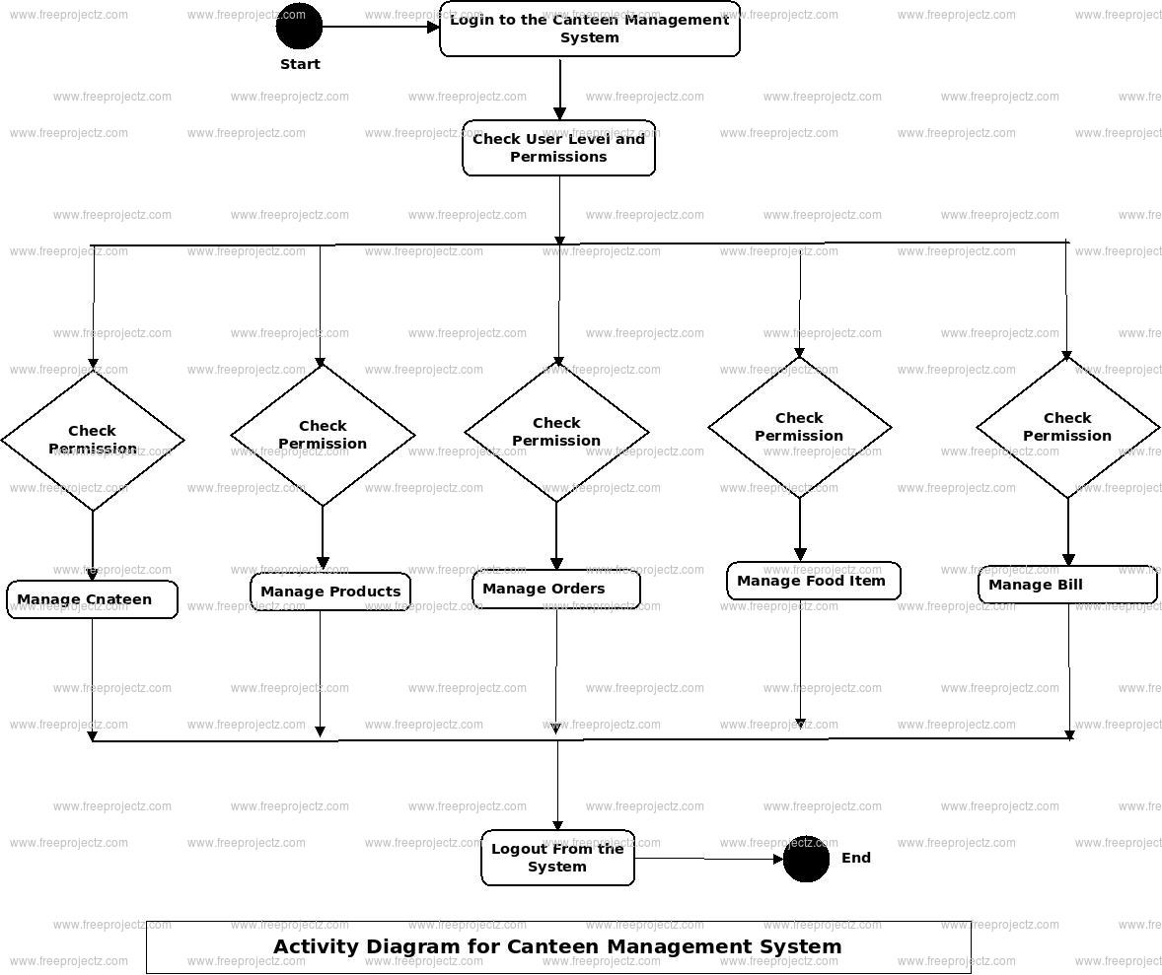

**Work flow of the diagram:**

1. In the registration section, we have fields such as email, username, and setting the password.
2. In the sign in section, we have to enter our username and password and if it is correct, it gets redirected to the home page.
3. There are items to be adding to cart.
4. And after adding to cart. We can remove it from the cart or else we can proceed to checkout.
5. In the payment section, after paying the amount, we will be allocated a table number and the order id.

**Screenshots:**

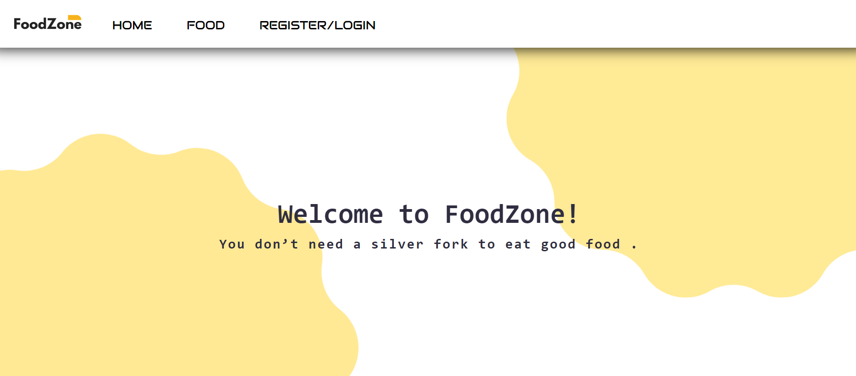

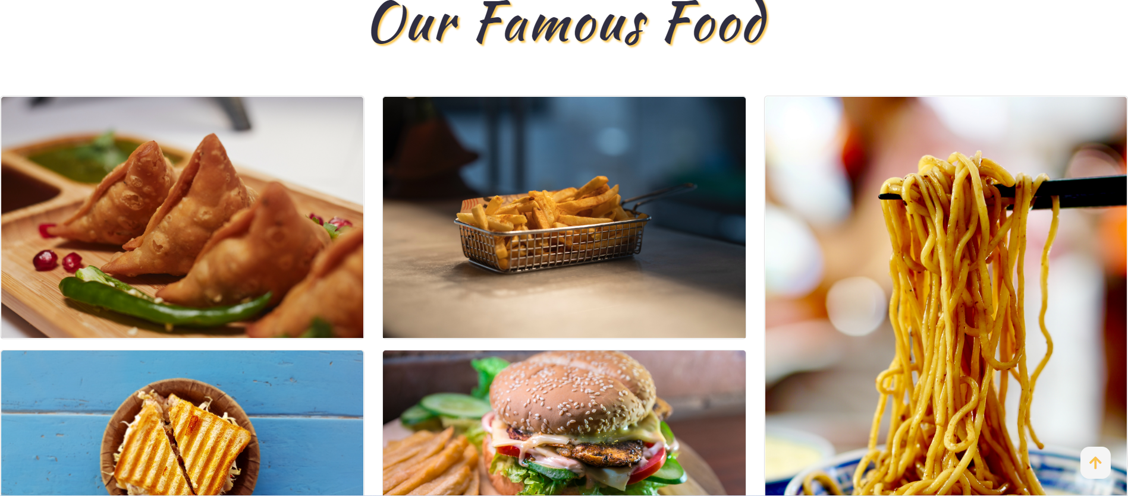

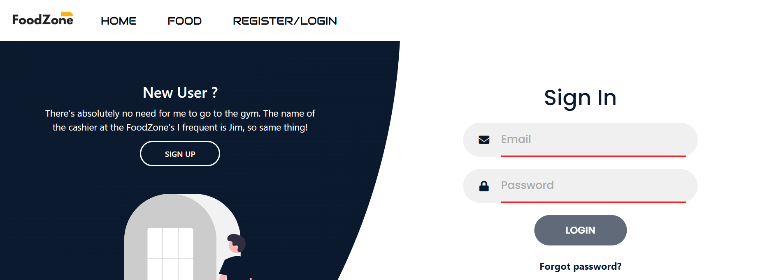

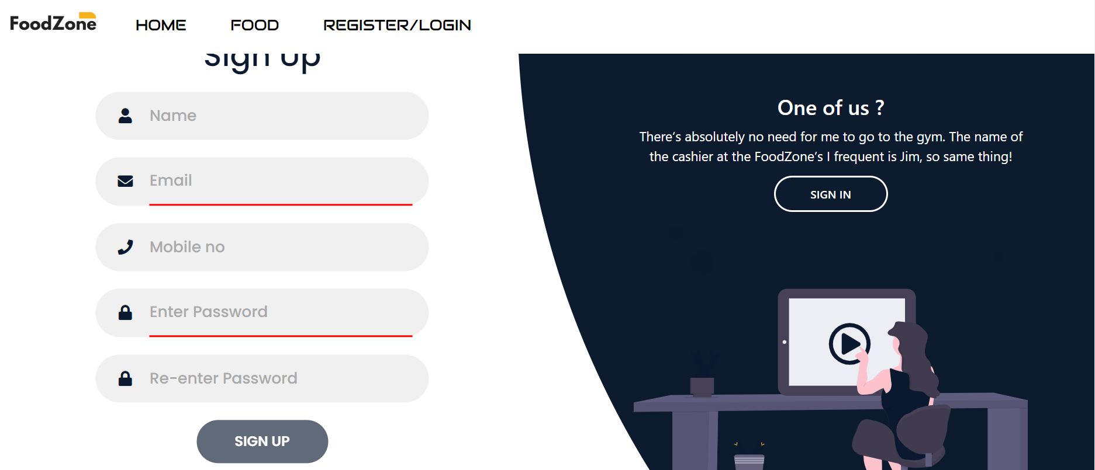

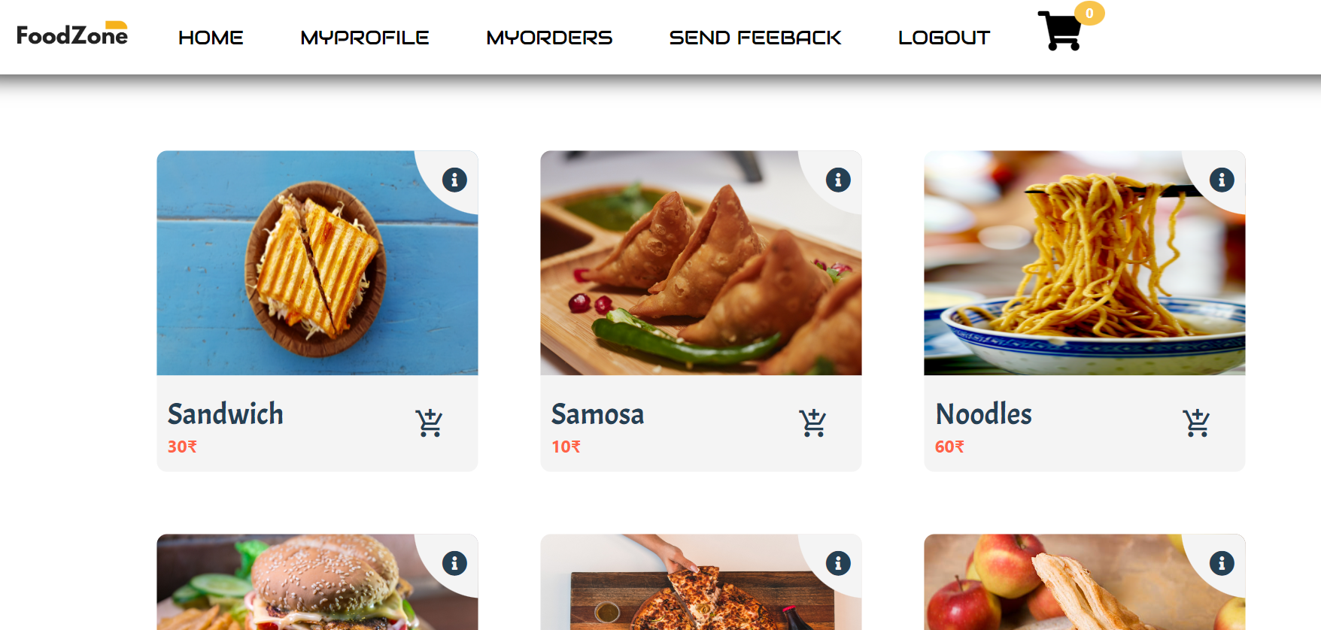

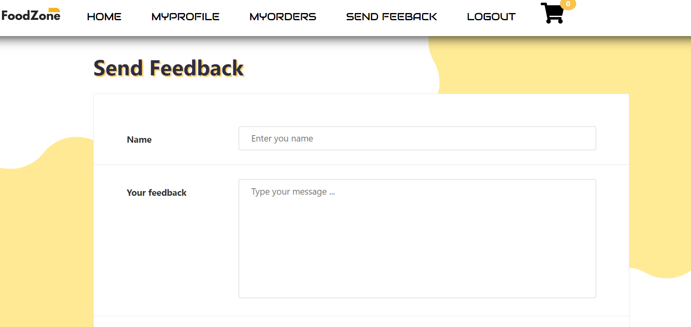

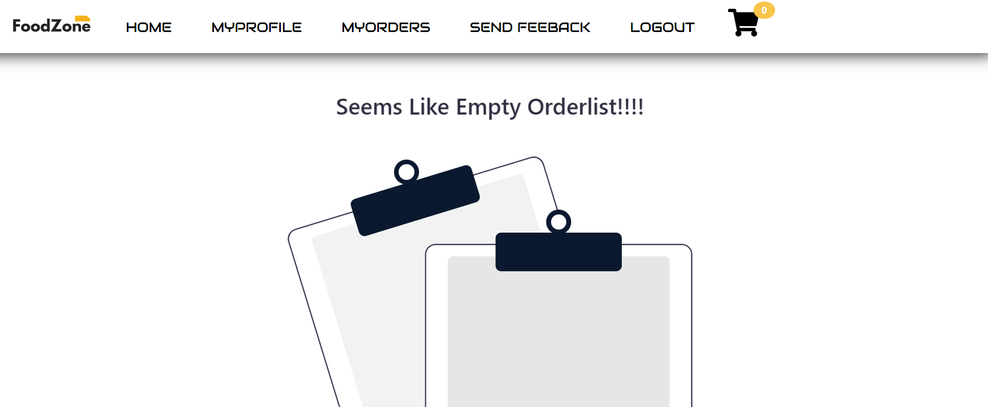

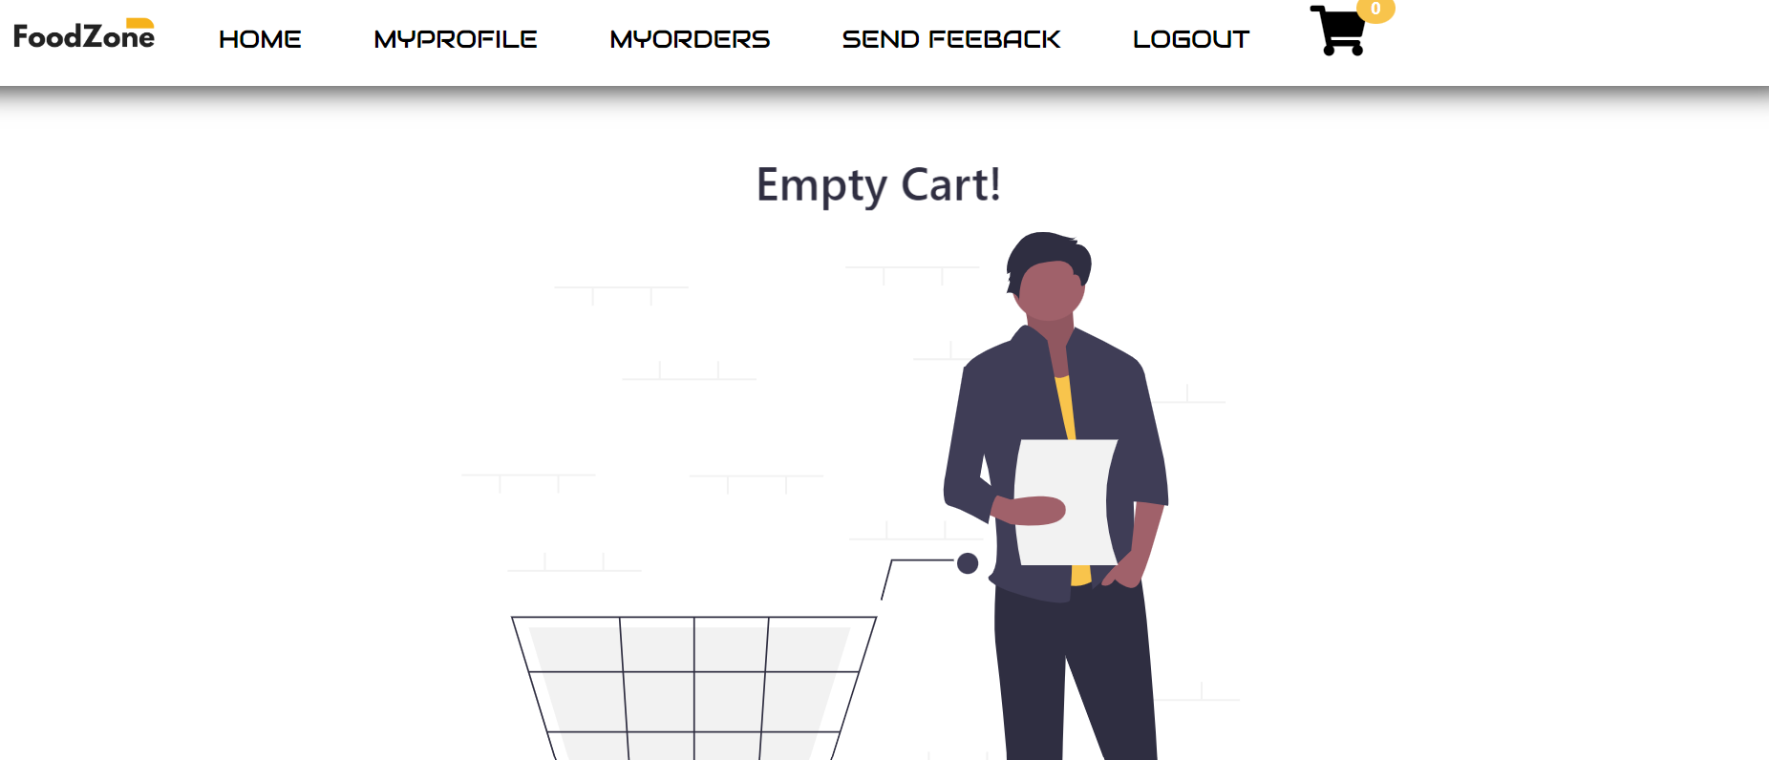

**XML:**

|  |  |  |
| --- | --- | --- |
| Element Name | Data Type | Constraint |
| Name | String | #REQUIRED, a-z,A-Z |
| Orderid | PCDATA | 0-9 |
| username | PCDATA | a-z,A-Z |
| Phone no | INT | #REQUIRED,0-9, max-length=10 |
| price | PCDATA | 0-9 |
| order_date | PCDATA | D/m/y |

**Summary of Files:**

|  |  |  |
| --- | --- | --- |
| FormName/CSS/XML/DTD/XSD Name | File Name | Additional Information |
| Index | HTML,JS,CSS |  |
| Signup/Login | HTML, CSS, JS,DTD,XML |  |
| Payment | HTML, CSS, JS |  |
| Order | HTML, CSS, JS |  |
| Feedback | HTML, CSS, JS, XML,DTD |  |

**URL of the hosted website:**

<https://canteenmanagementsystem.netlify.app/>